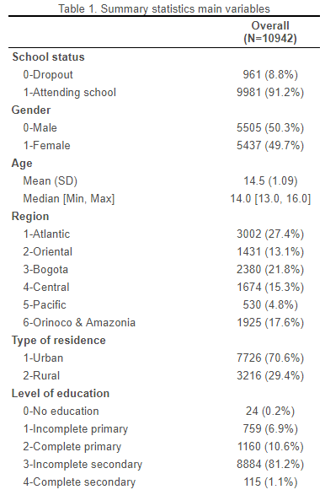

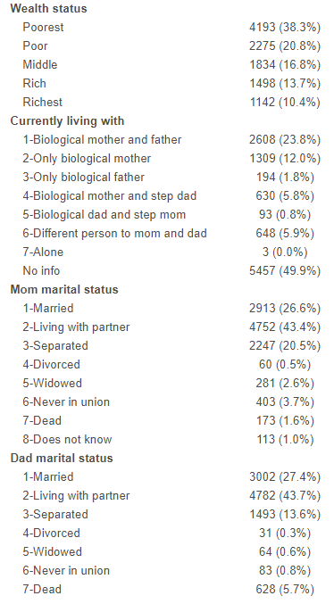

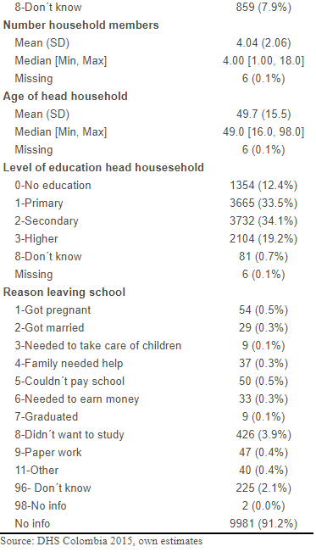

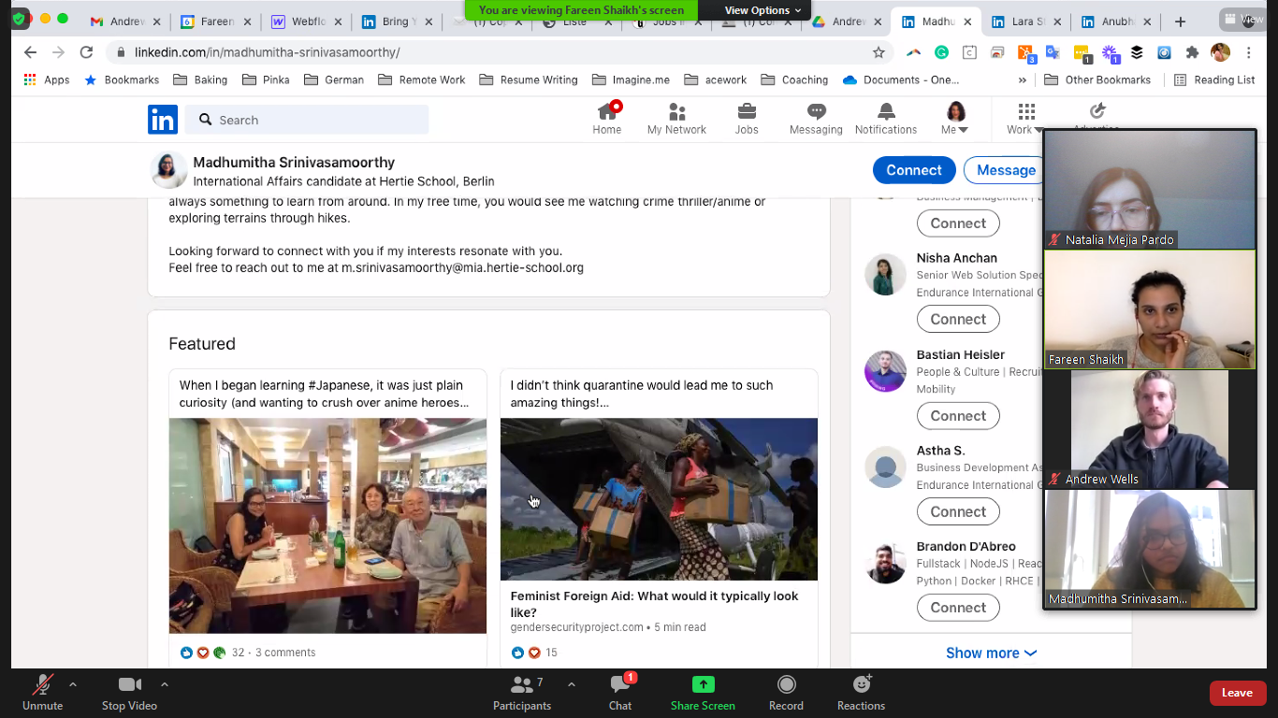

Eleanor joined The Futures Project in its very early stages. Working with her was a delight. She is very independent and proactive, quickly identifying opportunities, suggesting initiatives and following up. Her research and synthesis skills are excellent. She is a fast learner, open-minded, always eager to acquire new skills and knowledge. And, last but not least, she is a great team player and provided valuable support and guidance to more junior colleagues. Thank you, Eleanor, and all the best!

